Game Design Document

Fill up the Following document

1. Write the title of your project.

A1 THE TITLE OF MY PROJECT IS “MY PRECIOUS BIRDS ON MY PLANET,EARTH”.

1. What is the goal of the game?

A2 THE GOAL O F THE PROJECT IS TO PROTECT BIRDS FROM THE OBSACLES.

1. Write a brief story of your game?

A3 THE STORY OF MY GAME IS TO SPREAD AWARNESS ABOUT THE EXTENSION OF BIRDS AND TO SAVE THE BIRDS FROM HUNTERS.

1. Which are the playing characters of this game?

* Playing characters are the ones which respond to the user based on the input from the user
* Cars, monkeys, dinos, wizards etc, are the playing characters in the game.

|  |  |  |
| --- | --- | --- |
| Number | Character Name | What can this character do? |
| 1 | BIRDS | FLYING |
| 2 |  |  |
| 3 |  |  |
| 4 |  |  |
| 5 |  |  |
| 6 |  |  |
| 7 |  |  |
| 8 |  |  |

1. Which are the Non Playing Characters of this game?

* Non Playing characters are the ones which don't have an action or a behaviour when the user interacts with the game.
* Hurdles, stones, bananas, coins, etc are non playing characters in the game.

|  |  |  |
| --- | --- | --- |
| Number | Character Name | What can this character do? |
| 1 | PARACHUTE | OBSTACLES |
| 2 | AEROPLANE | OBSTACLES |
| 3 | SHIP | THROWS STONE |
| 4 |  |  |
| 5 |  |  |
| 6 |  |  |
| 7 |  |  |
| 8 |  |  |

Draw your imagination of this game. What does this game look like?

* Draw the game either on your computer or on paper,
* Add images of scenes of the game to show each of the playing and non-playing characters at least once.

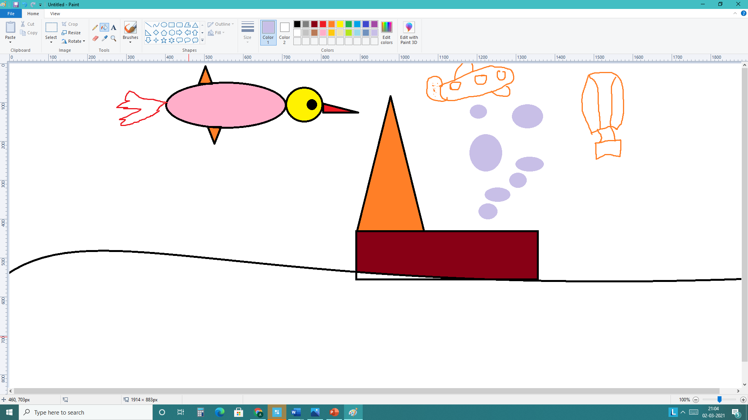

How do you plan to make your game engaging?

WE CAN MAKE OUR GAME ENGAGING BY ADDINGS ANIMATIONS AND SOUNDS.